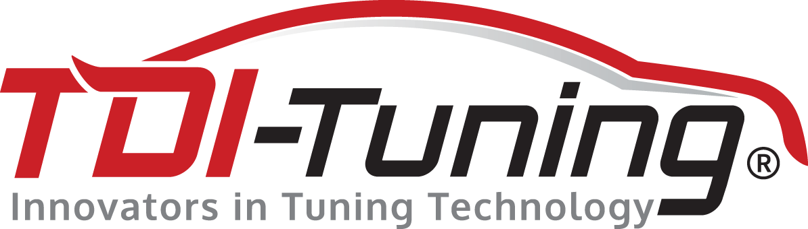

17 April 2015

FOR IMMEDIATE RELEASE

TDI-Tuning: petrol-style performance for diesel Porsches

Tuning firm closes gap between German sportcar marque’s diesel offering and its petrol variants
Macan’s launch last year increased the public’s interest in performance Sports Utility Vehicles

British tuning designer and engineering firm TDI-Tuning reports a marked increase in demand among owners of Porsche diesel vehicles, as the prestigious brand doubled its presence in the crossover segment with its new Macan last year. Around 15% of high-end performance vehicles equipped with a TDI-Tuning box are Porsches.

“Whilst not yet in Evoque territory in terms of sales, the Macan, added to the bigger Cayenne, opens up an entirely new universe of possibilities and market growth for Porsche,” says TDI-Tuning principal Graeme King. “High customer retention means that Macan buyers have had experience of petrol-engined Porsches before, and expect that kind of performance from their new, diesel-powered Porsche. This is why they come to TDI-Tuning: to close that gap, and make their diesel Macan, or Cayenne, faster and more efficient.”

The new Macan sales have helped Porsche achieve an increase of 12% in the UK, and the rise of diesel car market share here, as in Europe, has meant that more than of half of new car sales are now diesel-powered: this growth is reflected in TDI-Tuning’s tuning box demand from Porsche owners as they join other luxury brand car buyers wishing more performance and better fuel efficiency from their vehicle.

A Porsche Macan 3.0 V6, giving out 254bhp and 428lb ft of torque, fitted with a TDI-Tuning bespoke Twin Channel Diesel Tuning Box, will see its power increase to 320bhp and torque to 496lb ft; fuel efficiency is also improved by 4/6mpg.

TDI Tuning maintains a 100% positive feedback score through independent review service Feefo.

Some key points:

- TDI-Tuning designs and develops its own tuning boxes, which are then manufactured in Germany.
- The boxes are easy to plug in and/or remove, require no special skills or specialist input, and can be fitted by the end user in less than 30 minutes
- The vehicle will revert to standard when the box is removed - leaving no trace
- The tuning equipment can be sent back to TDI-Tuning to be re-programmed for over 4,000 different models
- TDI-Tuning boxes start at just under £300.

THE END

For further information contact: Angie Voluti, AV PR tel. 0203 632 5924/mob. 07415 095 543 angie@av-pr.com or Simon Lines, AV PR tel. 0203 632 5924/mob. 07903 502 942 simon@av-pr.com

AV PR | TDI Tuning Ltd
The Studio | Waterhouse Business Centre
194a Upper Richmond Road West, | Unit 26
London | Cromar Way
SW14 8AN | Chelmsford
tel. 00 44 (0) 203 632 5924 | Essex, CM1 2QE
Mob. 00 44 (0) 7415 095 543 | tel. 01245 392 255
 | Email: sales@tdi-tuning.co.uk
Website: www.angievoluti.com | Website: www.tdi-tuning.co.uk

